Exercises Biol-480 “Neuroscience” - Neuroanatomy and Techniques II Solutions (15/09/2025)

General Questions

- What system controls reactions to stress and regulates reproductive functions?

Hypothalamic–pituitary–adrenal (HPA) axis
- Which system is implicated in learning and memory? Give 2 examples of structures involved.

Lymbic system : Amygdala, Hippocampus.
- In the diagram below, label the five major divisions of the brain (Telencephalon, Diencephalon, Mesencephalon, Metencephalon, Myelencephalon)
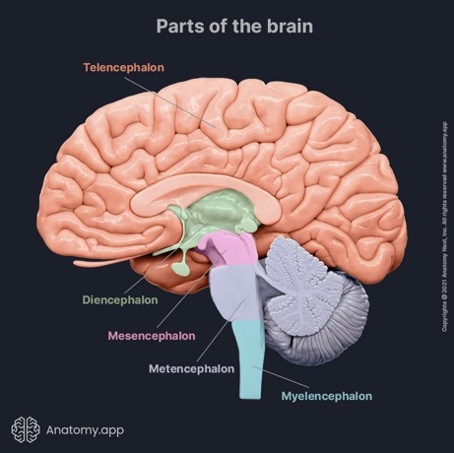

Clinical case 1

On the morning prior to presentation the patient awoke with decreased sensation in her right face and arm “as though they were asleep.” She had no difficulties with language, motor skills, or vision. Her symptoms continued until the next morning, when she also noticed loss of sensation in her right foot. She became concerned and came to her medical clinic for evaluation. Past medical history was notable for hypertension, cigarette smoking, and depression. Her father had a stroke at age 64.

The key symtoms are :
- Decreased primary sensation in half of the body, including the face, with no other deficits : decreased pinprick, temperature, vibration, and light touch sensation in the right face and body, with decreased two-point discrimination in the right hand

- Which structure contains the major sensory nuclei?
The thalamus.
- Which imaging technique would you use to observe this structure?
CT scan can be used but MRI would be more precise.
- On the image below (what type of image is it?), do you notice something unusual about the thalamus?
MRI image
Unilateral Infarct in the thalamus

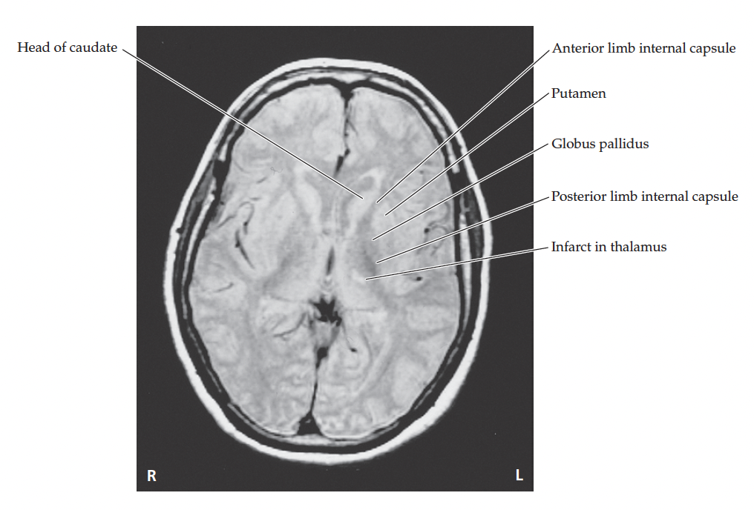

Clinical case 2

A 40-year-old, right-handed woman came to the emergency room because of unusual episodes. She had been healthy until 2 weeks previously, when she awoke one night from sleep and complained to her husband of an indescribable, unpleasant odor, nausea, and a panicky, fearful sensation. This lasted for 2 to 3 minutes, after which she felt very tired and went back to sleep. During the following week, while traveling with a Girl Scout troup, she began having stereotyped episodes about three times per day. These always began with panic, nausea, and a strong unpleasant odor “like smelling salts,” followed by decreased responsiveness and slow, inappropriate speech lasting 2 to 3 minutes. After each episode she had a bifrontal headache and felt very tired. On the day of presentation, she had six episodes of this kind, so her husband brought her to the emergency room. General exam and a detailed neurologic exam were normal.

- The patient seems to experience episodes of panic (no other emotions affected), olfactory hallucinations, and loss of awareness. On the basis of the symptoms, where in the brain is dysfunction occurring during the episodes?
Temporal lobe structures (limbic system), especially the medial temporal lobe (amygdala, hippocampus, olfactory cortex). These areas process fear, memory, and smell.
- Which imaging technique would you use to confirm the location of this dysfunction?
fMRI.
- What type of transient neurological episodes was this patient most likely experiencing?
Focal (partial) seizures.

Experiment

Li et al. (2020) showed that sustained voluntary wheel running not only improves motor skill learning but also induces a neurotransmitter switch in a subset of midbrain cholinergic neurons (caudal pedunculopontine nucleus, cPPN), shifting from acetylcholine (ACh) to GABA release.

- Which animal model would you use?
Mice
- What behavioral test would you choose to assess motor skill learning?
Rotarod
- Which technique(s) would you use to differentiate cholinergic from gabaergic neurons?
- Immunohistochemistry/immunofluorescence for marker of cholinergic neurons and marker of GABAergic neurons in the targeted brain area
- Western Blot
- Single-cell RNA sequencing for a more detailed view of neurotransmitter identity
- How would you test whether the neurotransmitter switch is functionally important for motor learning?
Use viral or genetic tools to block the switch and see if motor skill learning improvements after wheel running are abolished : the virus should be cell-type specific. To do this, we use cell-type specific promoters.

